# Introduction

## Purpose

This document specifies and explains the necessity of developing a software product hereinafter referred to as “PlasmaGraph” or “the product”. It also specifies the features and functions that the product delivers as well as providing a general explanation of what PlasmaGraph can and can’t do. The information contained in this document is intended to help Angel E. González-Lizard, Ph. D hereinafter referred to as “the client” to understand the product. Another use for this document can be as a starting point and guide of reference along the development process for Daniel E. Quintini and Gerardo A Navas hereinafter referred to as “the developers”.

## Scope

PlasmaGraph is intended to assists in the job of analyzing figures collected in experiments by providing a tool capable of processing a file with tabular data and produce a visual representation of the numbers within the file. The product has a graphical user interface that the user employs to select the file to be loaded, the address of the output file, the type of chart to be used and the columns being evaluated. PlasmaGraph will then be able to generate and save the chart as an image in portable network graphics format (*.png).

What the product does:

* Show a visual representation of a data set.
* Provide a graphical interface so the user can interact with the product.
* Create templates to interpret data sets in particular ways.
* Alert about possible errors in the uploaded data set.
* Suggest solutions for the error found in the data set uploaded.
* Fix any error found on the data set uploaded.
* Provide a graphical interface to configure the way a data set is visualized.
* Organize the data by column and criteria (alphabetical, numerical, ascending, and descending).
* Save all the configurations used when creating the visualization for any particular data set. This information will be used as a “template”

What the product does not do:

* Process files that are not formatted as comma-separated values.
* Catch 100% of possible errors.
* Fix 100% of detected errors.
* Find a solution for every detected error.

## Definitions, acronyms and abbreviations

*.png, GUI, software, *.csv

## References

## Overview

The rest of this document is divided in two sections which are overall description and specific requirements. The first describes the general factors that affect PlasmaGraph and its requirements. The second contains the requirements in a level of detail sufficient enough to enable the developers to design and test a system that meets the objectives defined.

The overall description of the product is divided into five subsections that defines the product’s perspective and functions, user characteristics, constrains, assumptions and dependencies. Meanwhile the specific requirements section spawns eight subsections covering external interfaces, functions, performance requirements, logical database requirements, design constrains, software systems attributes, organization of the specific requirements and any additional comments.

# Overall description

## Product perspective

PlasmaGraph is a software tool design to make visual representations of data sets. The product provides its user with a GUI to select the data file to be processed, specify how it is going to graph the data and whether or not to save these specifications to use later. PlasmaGraph will also ask the user where to save the image file generated with the data.

Because this software is intended to be used by Angel E. González-Lizard, Ph. D when analyzing experiment data from the PUPR plasma laboratory. The specific chart types provided by PlasmaGraph are TBD and they won’t be determined until Angel E. González-Lizard, Ph. D states which charts he uses most.

[comparer el sistema Nuevo con otro sistema]

### System Interfaces

PlasmaGraph is a composite of interfaces working together in order to transform a set of data into an image that is a graphical representation of that data. The two predominant interfaces are the user interface and the software interface:

The user interface (also referred as GUI) is the one that interacts with the person using the program. It is made of a series of windows populated with fields and buttons that enable the user to tell the program what to do.

The software interface won’t be accessible to the person using the program. It is made by a collection of functions that receive data from or send data to the GUI in order to perform the operations necessary to generate the graph or report the problem.

### User Interfaces

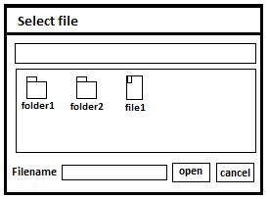

When PlasmaGraph starts, the user is going to see a window asking him/her to select a file. Using this window, the user can select the file containing the data that needs to be graphed.

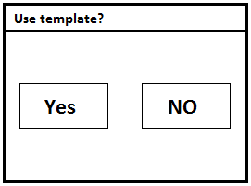

Once the user selects the file, another window is displayed asking if a template is going to be used. When the selection is made, the system proceeds to check the file for problems. If a problem is found, a message with a brief description of the problem is shown to the user. If the option selected was ‘Yes’, the system will provide another window with a list of charts to select from and once the chart is chosen, a set of options is provided inside the window so the user can control how the data is going to be displayed in the chart (charts and their configurations are TBD until a meeting with Angel E. González-Lizard, Ph. D is scheduled to resolve this problem). If the option selected when asked to use a template is ‘No’, then the same window with a list of charts will appear but the chart and all its options will be already selected. This last window also has two buttons, one to save the chart and another to save the chart and the options used as new template.

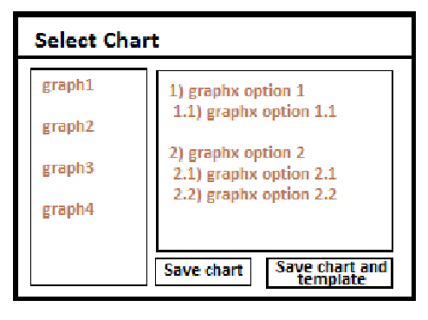

When the user proceeds to save the chart/template, the system will use the data provided to make an image file and display a window asking the user where to save the image. If a problem occurs, then a window with a brief description of the problem is shown and the PlasmaGraph program is terminated.

### Hardware Interfaces

[poner monitor, teclado, mouse, pon todo el hardware que necesitas][yo aisladamente lo puedo hacer]

Because PlasmaGraph runs in the Java VM, the hardware interface is defined by Java

### Software Interfaces

PlasmaGraph runs on the Java VM and uses several libraries to accomplish its requirements. These libraries are:

* OpenCSV
* JavaX.xml
* JFreeChart

### Memory

TBD (for this section to be determined, a prototype of PlasmaGraph should be evaluated first)

### Site Adaptation Requirements

For PlasmaGraph to function, Java must be installed.

## Product functions

This product performs functions like: analyze data from a preformatted file, fix problems in the data, generate and save graphical representation of the data and store in a template the options selected to graph the data.

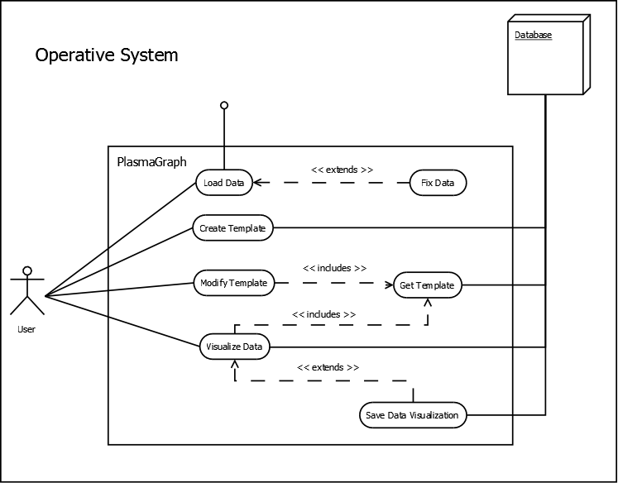

## User characteristics

The product is used by Angel E. González-Lizard, Ph. D as a tool to analyze experiment’s data from the plasma laboratory at the Polytechnic University of Puerto Rico. The user needs to know how to interact with a window based interface and how to read the chart types provided.

## Constraints

The product will only recognize a handful of problems with the data provided by the user and even then it won’t be able to fix all the problems (specifics of these problems are TDB until a meeting is scheduled with Angel E. González-Lizard, Ph. D to resolve the issue).

## Assumptions and dependencies

For PlasmaGraph to execute, Java VM must be running

# Specific requirements

## External interfaces

## Functions

[Use case scenarios here] fix

## Performance requirements

## Logical database requirements

## Design constraints

### Standards compliance

## Software system attributes

### Reliability

### Availability

### Security

### Maintainability

### Portability

## Organizing the specific requirements

### System mode

### User class

### Objects

### Feature

### Stimulus

### Response

### Functional hierarchy

## Additional comments